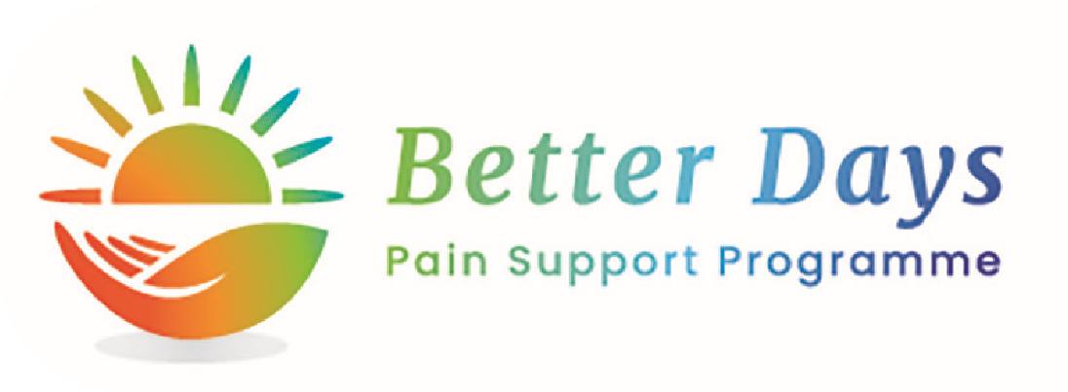

Supporting people

to self-manage their

pain and live better

and happier lives

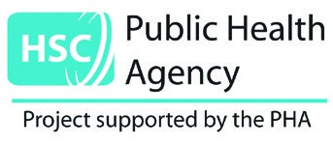

My pain had overwhelmed me

and I had lost my confidence

and drive.

This course has built my confidence and

improved my motivation and self-worth.

I am now more confident in being able

to manage my own pain and I

have a more positive outlook

Do you live with

chronic pain?



Carole, 53, Belfast

For more information contact

Natasha Moore | Pain Programme Co-ordinator

E:

nmoore@lorag.org |

T:

028 90312377 ext.2

M:

07939406277



Topics include:



For more information please contact us.

Details overleaf



Take 5 Steps to Wellbeing

Pain Toolkit

Understanding Pain

Relaxation & Breathing

Nutrition

Sleep

Self Care

Pharmacist Session

Gentle Movement & Exercise

Peer Led Session